Brockwell ~Holly Point Way~ Cemetery
Visited by Members of
Grave Site Survey Task Force (GSSTF)
Under the Auspices of
Isle of Wight County Historical Society (IWCHS)
March 10, 2004

The cemetery is located off of Holly Point Way (# 675) about 0.3 miles east of state route # 10 (Old Stage Hwy). It is very heavily overgrown and extremely difficult to locate any buried tombstones. Team members did some limited probing and found the existence of 4 unmarked graves in addition to the three graves that carried inscriptions.
The iron fencing around one section of the cemetery is quite ornate as depicted in Figures 5, 6 and 7. Springfield Architectural Ironworks in Springfield, Ohio manufactured it.

Please address your comments/corrections to: albert.b@charter.net or epowellsr@aol.com

Note # | Inscription |  | Note # | Inscription
 | CLAUDE B.  BROCKWELL  1857 1923  “Twas hard to give thee up  But thy will O’God be done” |  |  | L. L. BROCKWELL  1856 1918
MARY V.
BROCKWELL
Born Oct. 26, 1869
Died Aug. 22, 1938
“At Rest”

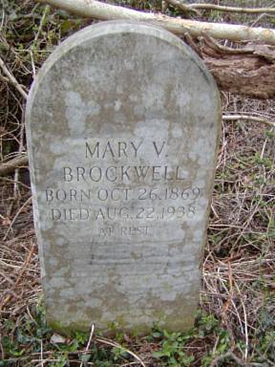 | 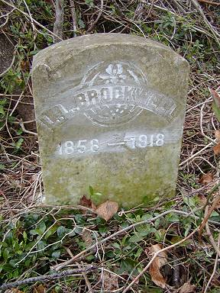
Figure 1 | Figure 2
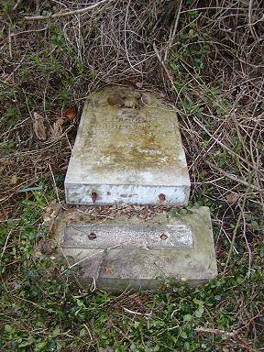 | 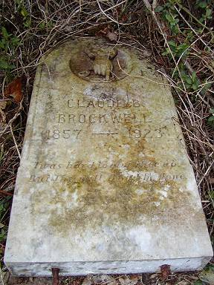
Figure 3 | Figure 4
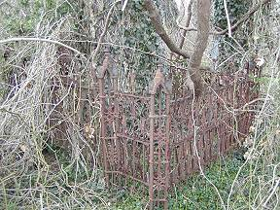 | 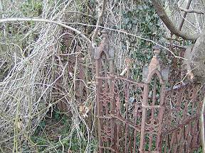
Figure 5 | Figure 6
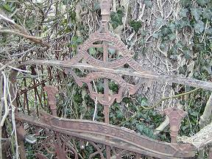 | 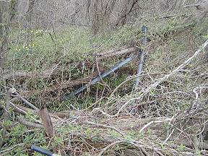
Figure 7 | Figure 8

