Carr ~Collosse Rd~ Cemetery
Visited by Members of
Grave Site Survey Task Force (GSSTF)
Under the Auspices of
Isle of Wight County Historical Society (IWCHS)
February 5, 8, 2006
(Correction made April 17, 2021)

A selection of shaving foam, water, or talcum powder was used to improve the legibility of the inscriptions on the older tombstones. Afterwards, a clean water spray was used to remove any residue. GSSTF members were careful not to damage tombstones or artifacts during the transcription process.

Any text within the “[ ]” is a comment about the tombstone inscription, ex., [fs] indicates a footstone inscription. Throughout the transcribing process, an attempt was made to preserve the, ‘look and feel’ of the original inscriptions as regards word spacing, arrangement, and possible misspellings.

Please address your comments/corrections to: albert.b@charter.net or epowellsr@aol.com.

 | Inscription |  |  | Inscription
 | MARTHA SARAH  wife of  JOHN T. CARR  June 12, 1861  October 29, 1929  Gone, But Not Forgotten |  |  | JOHN T. CARR  February 16, 1855  January 18, 1934  He Died as He Lived, A Christian
 | Blank marker |  |  | HARDY  CARR
 | MICAJAH  CARR |  |  | ELIZABETH  CARR  [stone is broken]

The following information was obtained during an interview with the landowner:

Hardy Carr married Elizabeth Carr (d/o John Carr & Marguerite) on 20 July 1822 by Jonathan Lankford.
Hardy Carr (born about 1800 and died between 1840-1850)
Elizabeth Carr (born about 1801 and died 20 Dec 1890)
Micajah Carr (born about 1827 and died 20 Dec 1857) married Caroline Virginia Stephenson on 15 Feb 1854. John T Carr is son of Micajah & Caroline, raised by grandmother Elizabeth Carr.
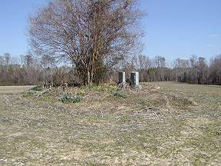 | 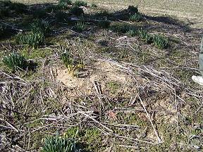
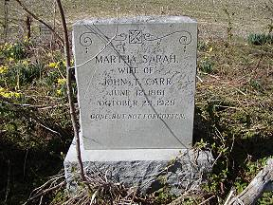 | 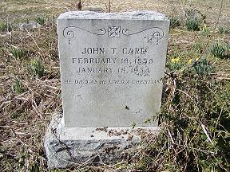
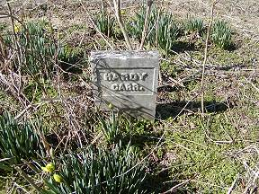 | 