Manley ~Honeysuckle Ln~ Cemetery
Visited by Members of
Grave Site Survey Task Force (GSSTF)
Under the Auspices of
Isle of Wight County Historical Society (IWCHS)
February 5, 8, 2006

A selection of shaving foam, water, or talcum powder was used to improve the legibility of the inscriptions on the older tombstones. Afterwards, a clean water spray was used to remove any residue. GSSTF members were careful not to damage tombstones or artifacts during the transcription process.

Any text within the “[ ]” is a comment about the tombstone inscription, ex., [fs] indicates a footstone inscription. Throughout the transcribing process, an attempt was made to preserve the, ‘look and feel’ of the original inscriptions as regards word spacing, arrangement, and possible misspellings.

Please address your comments/corrections to: albert.b@charter.net or epowellsr@aol.com.

 | Inscription |  |  | Inscription
 | SYLVIA GAY HILLIARD  July 20, 1953  December 27, 2001 |  |  | VANESSA G. CAMBELL  July 20, 1959  Mar 12, 1985
 | BEULAH B. MANLEY  Oct. 18, 1897  Feb. 4, 1983  Gone But Not Forgotten |  |  | RUFFIN MANLEY  June 19, 1898  June 7, 1960  Gone But Not Forgotten  Father [fs]
HORACE I.
MANLEY
U S ARMY
KOREA
Oct 30, 1932
Apr 10, 2004

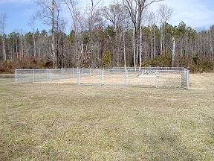 | 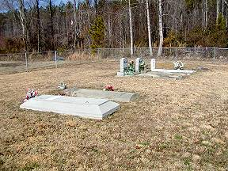
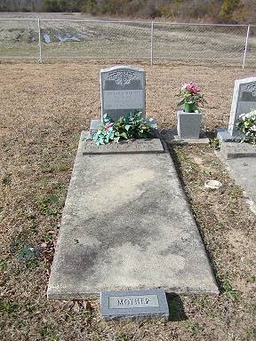 | 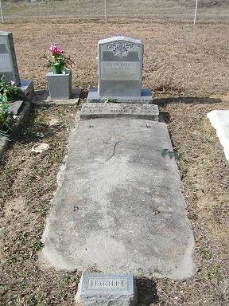
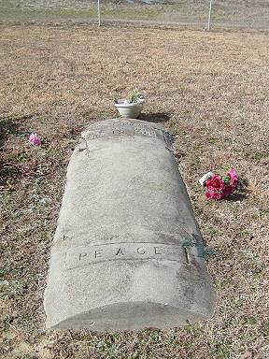 | 