Mitchell ~Joyners Bridge Rd~ Cemetery
Transcribed by members of the
Grave Site Survey Task Force (GSSTF)
Under the Auspices of
Isle of Wight County Historical Society (IWCHS)
Visited Oct 20, 2013

A selection of shaving foam, water, or talcum powder was used to improve the legibility of the inscriptions on the older tombstones. Afterwards, a clean water spray was used to remove any residue. GSSTF members were careful not to damage tombstones or artifacts during the transcription process. Note: If the actual name of the cemetery is not known, then the preponderance of names of persons buried there will be the cemetery name for recording purposes.

Any text within the “[ ]” is a comment about the tombstone inscription, ex., [fs] indicates a footstone inscription. Throughout the transcribing process, an attempt was made to preserve the, ‘look and feel’ of the original inscriptions as regards word spacing, arrangement, and possible misspellings.

Please address your comments/corrections to: albert.b@charter.net or epowellsr@aol.com.

 | Inscription |  |  | Inscription
 | WILLIAM J. STOKES  March 3, 1916  Aug 22, 1986 |  |  | LUKE STOKES  Dec. 18, 1887  Nov 25, 1971
 | MARTHA P. MITCHELL  Born Nov. 15, 1865  Died March 28, 1929 |  |  | JOSEPH M. MITCHELL  Born June 15, 1862  Died March 11, 1952
 | LEWIS C. MITCHELL  Sept. 2, 1902  Aug 9, 1989 |  |  | LAVENIA MITCHELL  Jan 15, 1911  March 5, 1990
 | JEAN CUTLER  Born Jan. 11, 1928  Died Nov. 8, 1951 |  |  | CHARLOTTE V. HINES  Oct. 7, 1898  July 4, 1972
 | GERTIE A. STOKES  Born March 12, 1887  Died May 10, 1957 |  |  | WILBUR HINES  Jan. 28, 1908  Oct. 28, 1978
MARTHA M. RAWLINS
Oct. l7 1898
Aug. 31, 1982

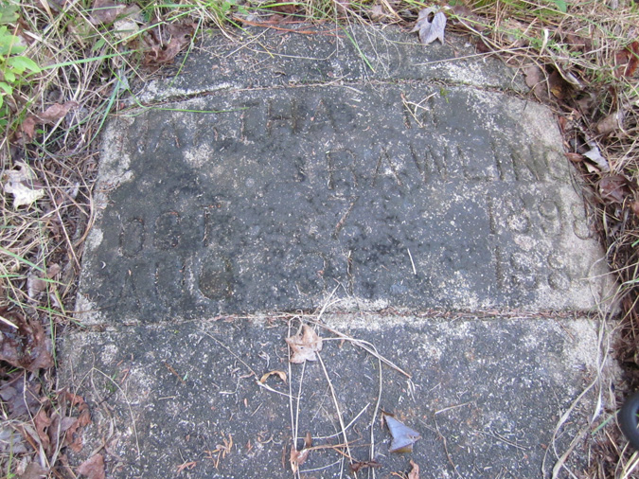 | 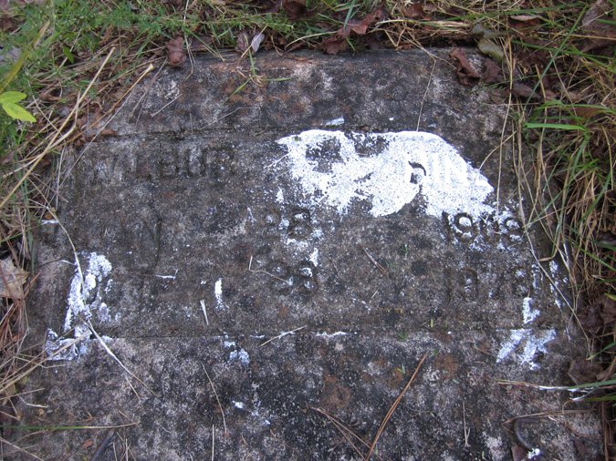
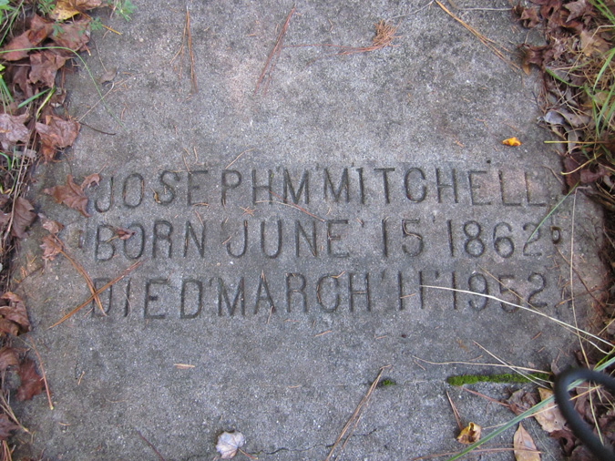 | 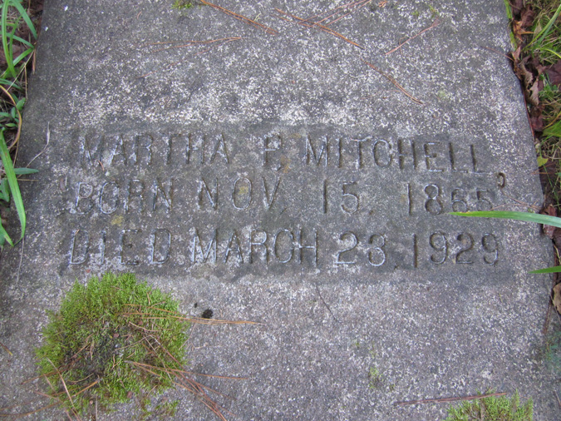
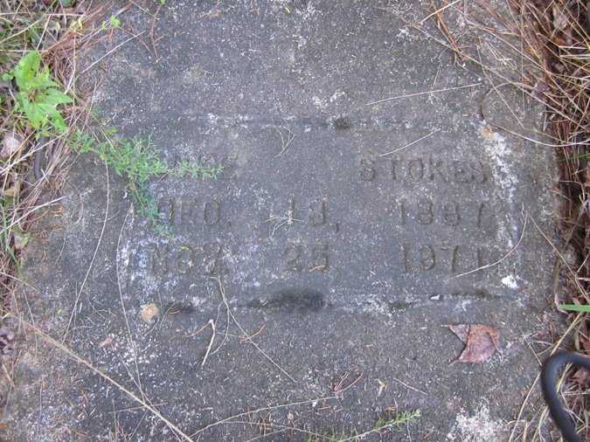 | 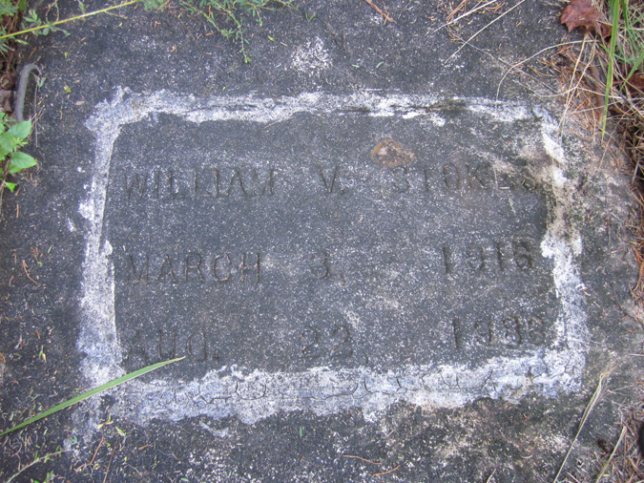
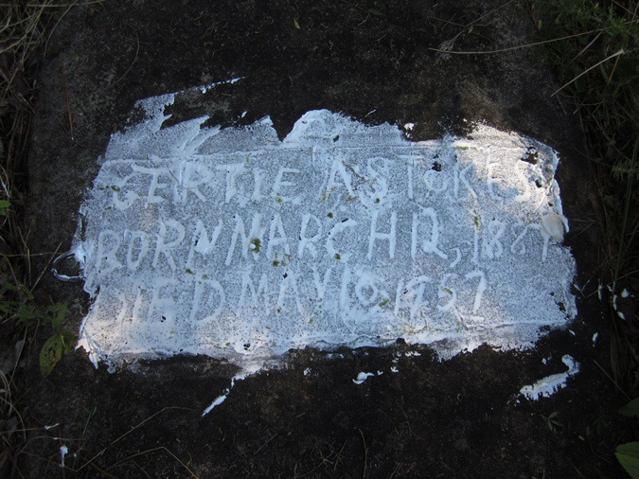 | 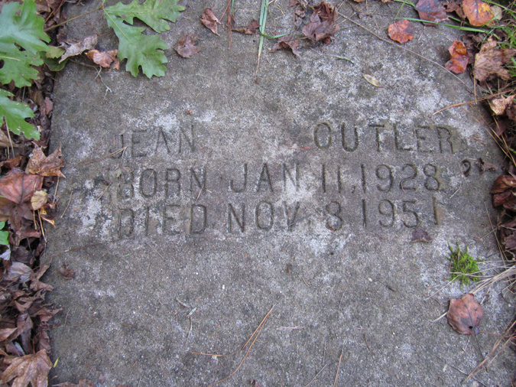
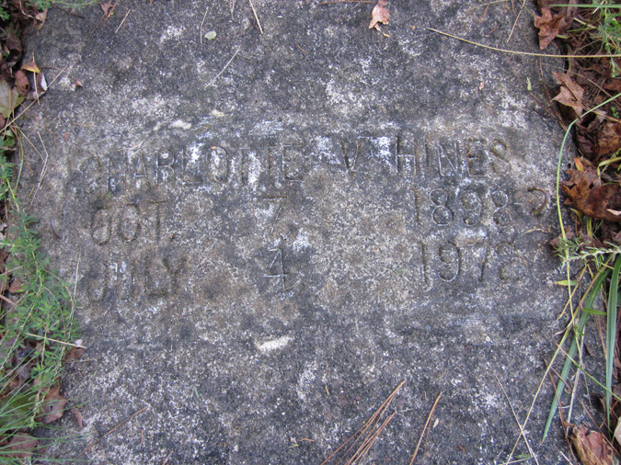 | 